Project Plan

About Us

Suggestions

Events

Search a book

LOGIN

BANNER

Title & Menu Bar

#Main Page

Title & Menu Bar

SEARCH A BOOK

Search

Book Title

Possible results

Back

#Search a Book

Title & Menu Bar

Upcoming Events

Back

EVENTS

SEARCH A BOOK

#Upcoming Events

Title & Menu Bar

E Book

Hyperlinks for E book

Back

#Upcoming Events

E Books

#E books

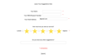

Title & Menu Bar

Back

Suggestions

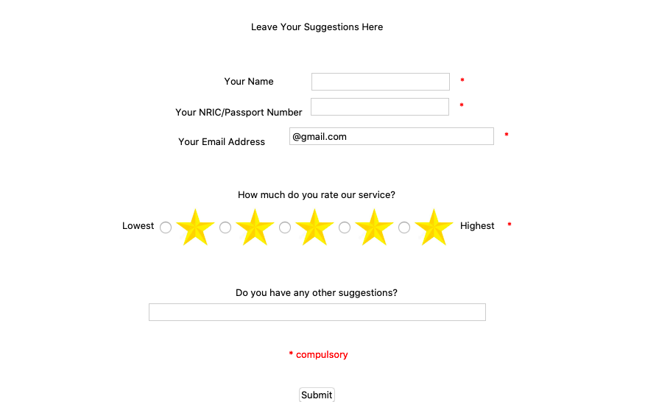

SEARCH A BOOK

#Feed back



Title & Menu Bar

Back

About us

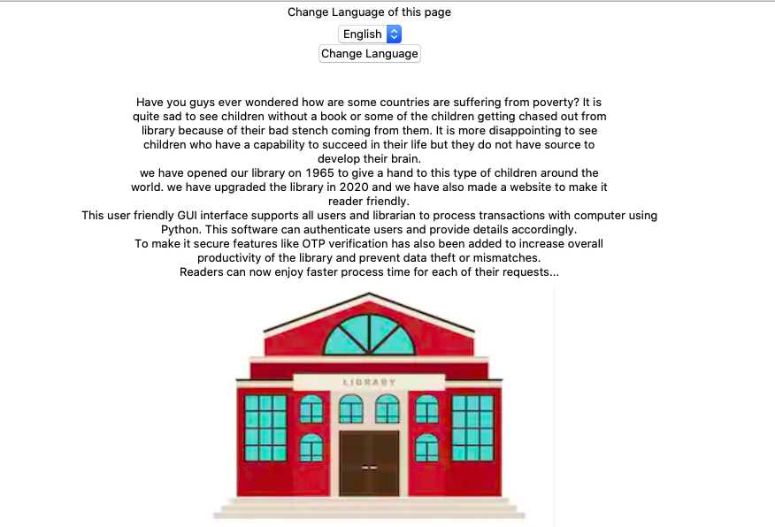

SEARCH A BOOK

#About us



Title & Menu Bar

Back

Login

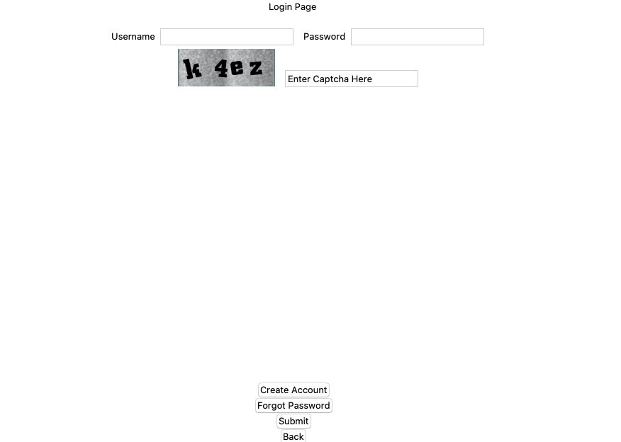



SEARCH A BOOK

#Login



Title & Menu Bar

Back

Forgot Password

SEARCH A BOOK

Username

Phone No

Email

Captcha

OTP

New Password

#Forgot Password



Title & Menu Bar

Back

Create account

SEARCH A BOOK

Username

Fname, Lname

Phone No

Email

Password

Captcha

OTP

New Password

#Create Account

Log Out

Search Book

Inbox

Reservations

Return

Title & Menu Bar

Overdue books

Notifications

Borrow

#Librarian A/c

Notes 🡪 in borrowing, after borrowing a book, ask if want to borrow another book

Log Out

Donate

Title & Menu Bar

Add New Books

Events update

Users and Account

Notifications

Inbox

#Admin A/c

Have option such that registered people become official users only if admin accepts it

Log Out

Upcoming events

Donate books

Make

Reservations

Title & Menu Bar

Write to Admin / librarian

Notifications

Search Book

view

Borrowed Books

#Users A/c

Other Notes & Add On

Log out & sleep for some time with a message please wait for some time

& add some quotes

Donate books in log in interface

Help

Report section

Checking overdue books for librarians

Generating notifications for users regarding a new book is out, etc.

In project report add unique features

Nric last 4 characters

Pls remember id msg in email

Text in captcha